# Use Azure Synapse Link for Azure Cosmos DB

Azure Synapse Link for Azure Cosmos DB is a cloud-native hybrid transactional analytical processing (HTAP) technology that enables you to run near-real-time analytics over operational data stored in Azure Cosmos DB from Azure Synapse Analytics.

This exercise should take approximately ****35**** minutes to complete.

## Before you start

You’ll need an [Azure subscription](https://azure.microsoft.com/free) in which you have administrative-level access.

## Provision Azure resources

1. In the PowerShell pane, enter the following commands to clone this repo:

rm -r dp-203 -f

git clone https://github.com/MicrosoftLearning/dp-203-azure-data-engineer dp-203

1. After the repo has been cloned, enter the following commands to change to the folder for this exercise and run the ****setup.ps1**** script it contains:

cd dp-203/Allfiles/labs/14

./setup.ps1

## Configure Synapse Link in Azure Cosmos DB

Before you can use Synapse Link for Azure Cosmos DB, you must enable it in your Azure Cosmos DB account and configure a container as an analytical store.

### Enable the Synapse Link feature in your Cosmos DB account

1. In the [Azure portal](https://portal.azure.com/), browse to the ****dp203-**xxxxxxx** resource group that was created by the setup script, and identify your ****cosmos**xxxxxxxx** Cosmos DB account.

****Note****: In some cases, the script may have tried to create Cosmos DB accounts in multiple regions, so there may be one or more accounts in a deleting state. The active account should be the one with the largest number at the end of its name - for example ****cosmos**xxxxxxx**3****.

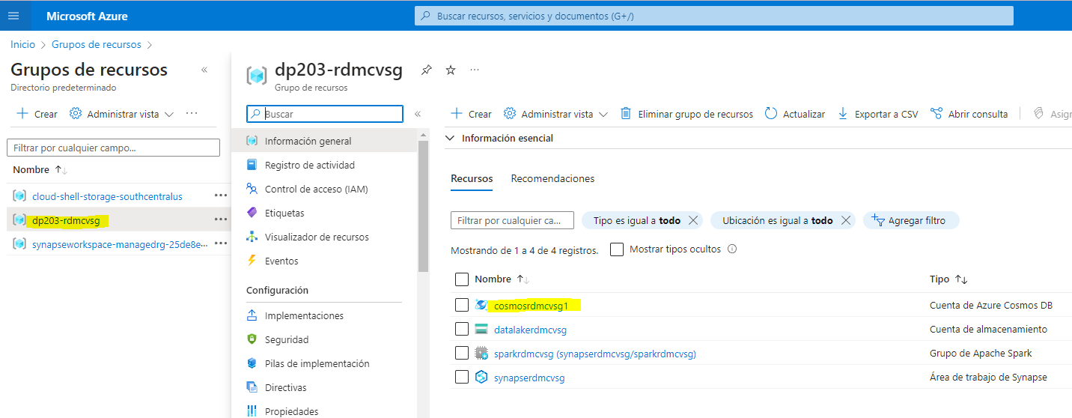

1. Open your Azure Cosmos DB account, and select the ****Data Explorer**** page on the left side of its blade.

If a ****Welcome**** dialog box is displayed, close it

1. At the top of the ****Data Explorer**** page, use the ****Enable Azure Synapse Link**** button to enable Synapse Link.

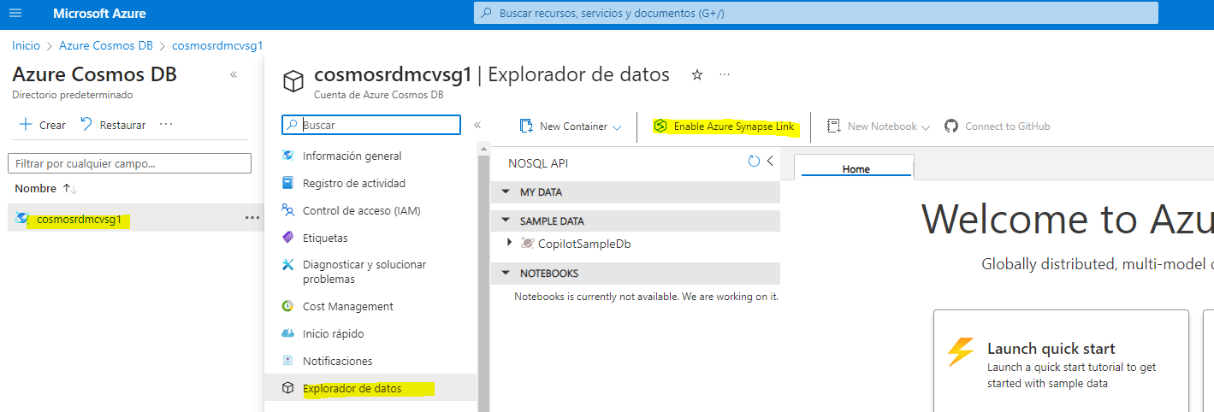

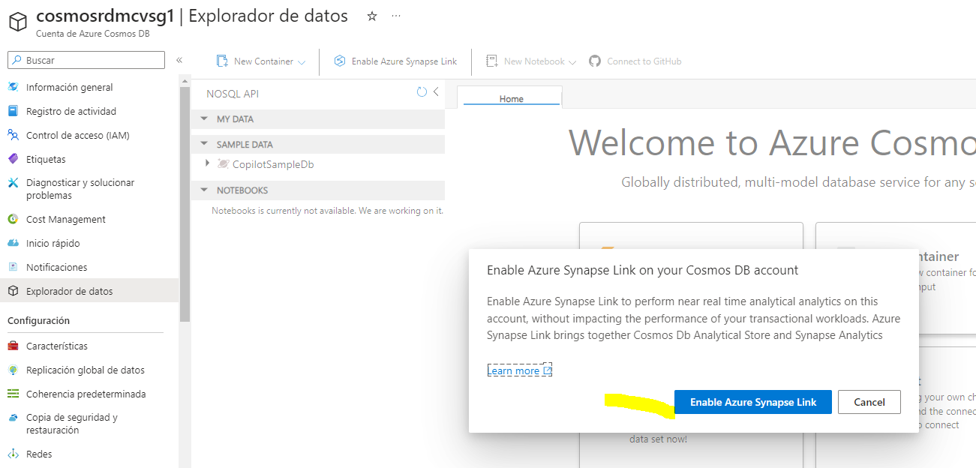

1. On the left side of the page, in the ****Integrations**** section, select the ****Azure Synapse Link**** page and verify that the status of the account is Enabled.

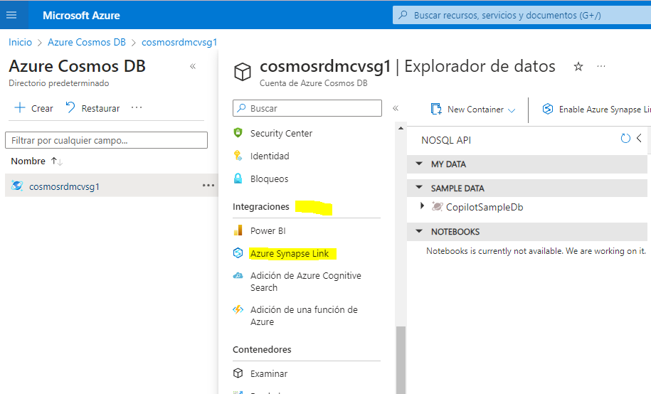

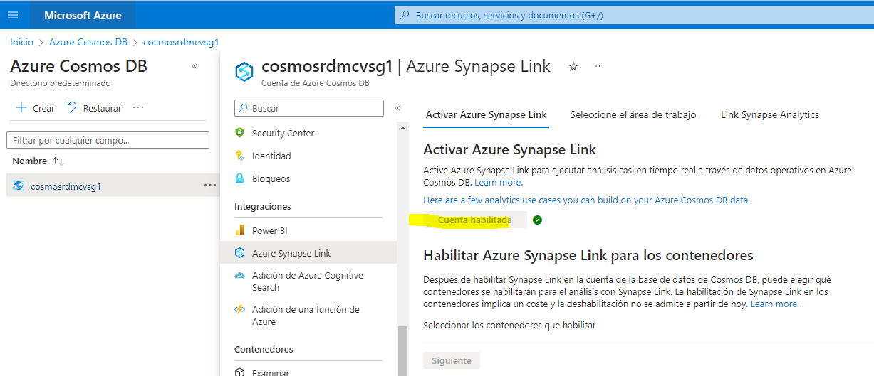

### Create an analytical store container

1. Return to the ****Data Explorer**** page, and use the ****new Container**** button (or tile) to create a new container with the following settings:

* ****Database id****: (Create new)
* ****Share throughput across containers****: Unselected
* ****Container id****: Sales
* ****Partition key****: /customerid
* ****Container throughput (autoscale)****: Autoscale
* ****Container Max RU/s****: 4000
* ****Analytical store****: On

****Note****: In this scenario, ****customerid**** is used for partition key as it’s likely to be used in many queries to retrieve customer and sales order information in a hypothetical application, it has relatively high cardinality (number of unique values), so it will allow the container to scale as the number of customers and sales orders grows. Using autoscale and setting the maximum value to 4000 RU/s is appropriate for a new application with initially low query volumes. A max value 4000 RU/s will enable the container to automatically scale between this value all the way down to 10% of this max value (400 RU/s) when not needed.

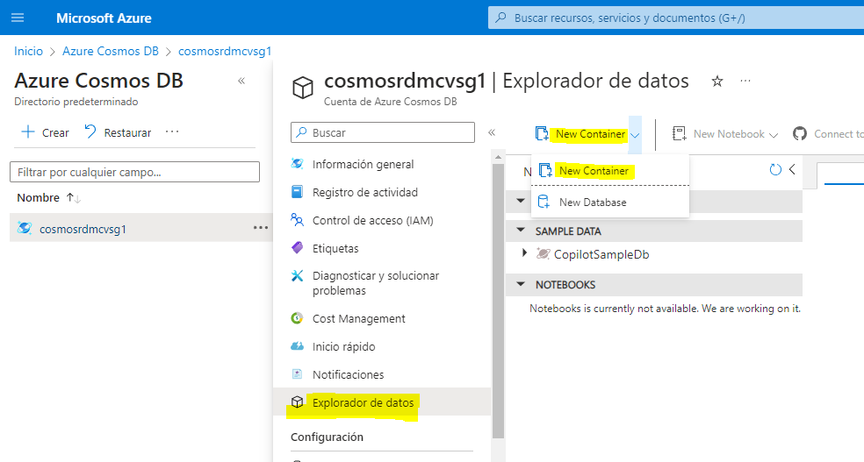

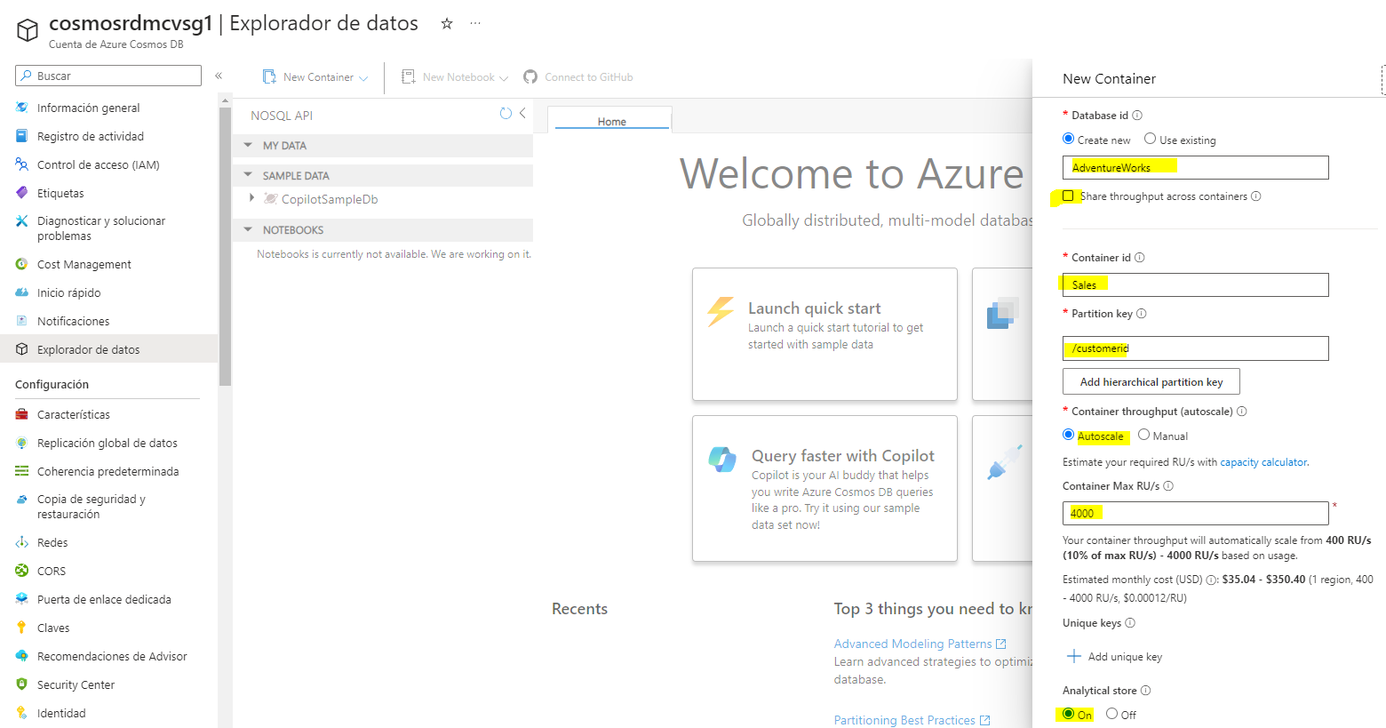

1. After the container has been created, in the ****Data Explorer**** page, expand the ****AdventureWorks**** database and its ****Sales**** folder; and then select the ****Items**** folder.

[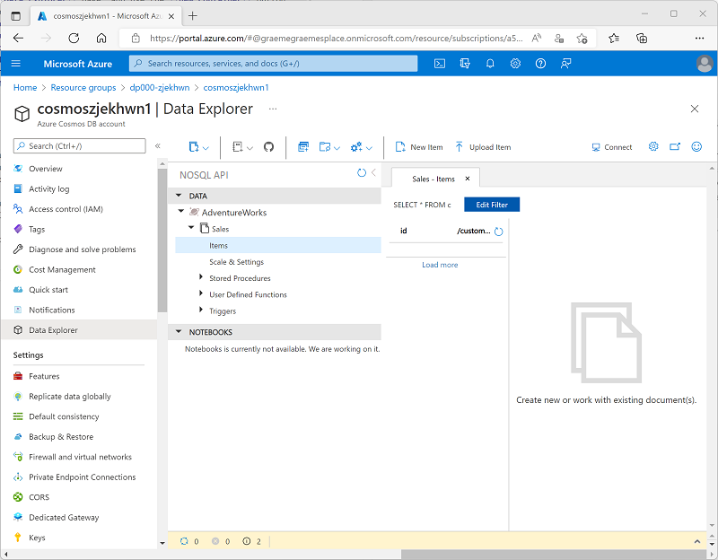](https://microsoftlearning.github.io/dp-203-azure-data-engineer/Instructions/Labs/images/cosmos-items-folder.png)

1. Use the ****New Item**** button to create a new customer item based on the following JSON. Then save the new item (some additional metadata fields will be added when you save the item).

{

"id": "SO43701",

"orderdate": "2019-07-01",

"customerid": 123,

"customerdetails": {

"customername": "Christy Zhu",

"customeremail": "christy12@adventure-works.com"

},

"product": "Mountain-100 Silver, 44",

"quantity": 1,

"price": 3399.99

}

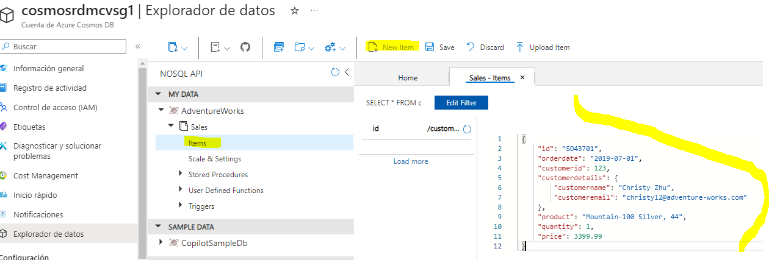

1. Add a second item with the following JSON:

{

"id": "SO43704",

"orderdate": "2019-07-01",

"customerid": 124,

"customerdetails": {

"customername": "Julio Ruiz",

"customeremail": "julio1@adventure-works.com"

},

"product": "Mountain-100 Black, 48",

"quantity": 1,

"price": 3374.99

}

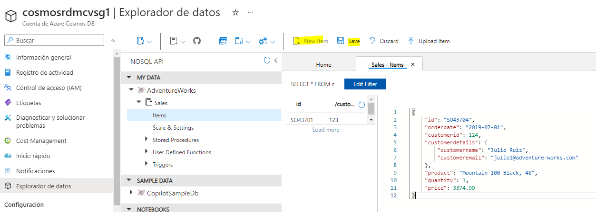

1. Add a third item with the following JSON:

{

"id": "SO43707",

"orderdate": "2019-07-02",

"customerid": 125,

"customerdetails": {

"customername": "Emma Brown",

"customeremail": "emma3@adventure-works.com"

},

"product": "Road-150 Red, 48",

"quantity": 1,

"price": 3578.27

}

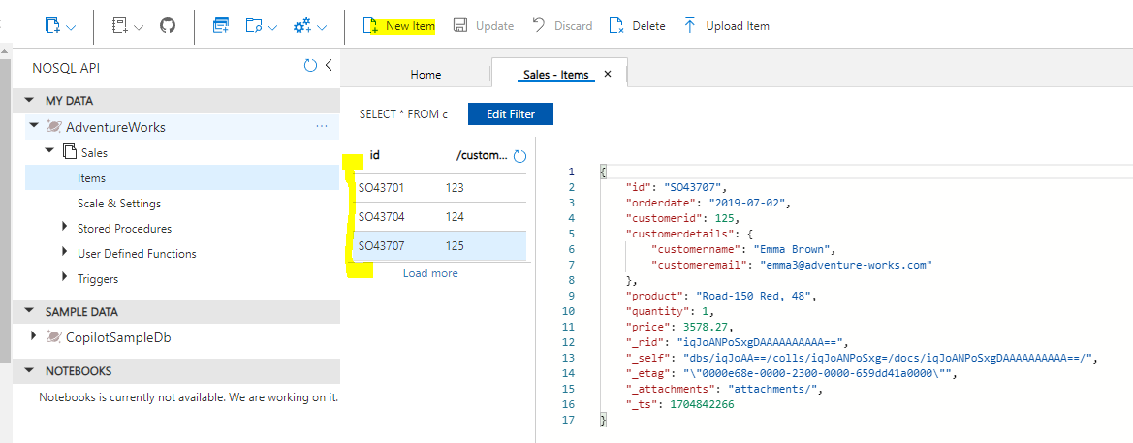

****Note****: In reality, the analytical store would contain a much larger volume of data, written to the store by an application. These few items will be sufficient to demonstrate the principle in this exercise.

## Configure Synapse Link in Azure Synapse Analytics

Now that you have prepared your Azure Cosmos DB account, you can configure Azure Synapse link for Azure Cosmos DB in your Azure Synapse Analytics workspace.

1. In the Azure portal, close the blade for your Cosmos DB account if it is still open, and return to the ****dp203-**xxxxxxx** resource group.
2. Open the ****synapse**xxxxxxx** Synapse workspace, and on its ****Overview**** page, in the ****Open Synapse Studio**** card, select ****Open**** to open Synapse Studio in a new browser tab; signing in if prompted.

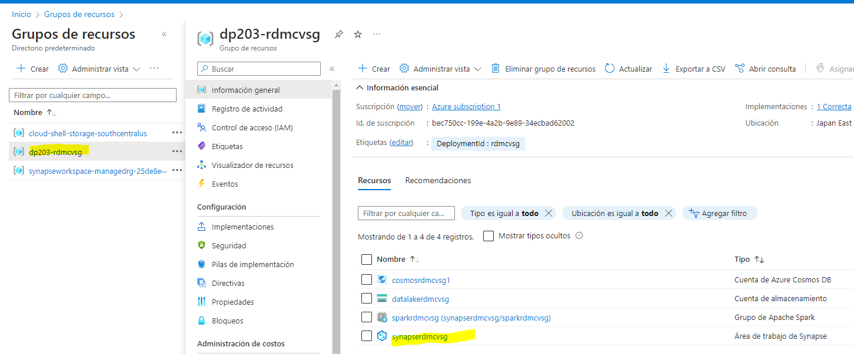

1. On the left side of Synapse Studio, use the ****››**** icon to expand the menu - this reveals the different pages within Synapse Studio.
2. On the ****Data**** page, view the ****Linked**** tab. Your workspace should already include a link to your Azure Data Lake Storage Gen2 storage account, but no link to your Cosmos DB account.

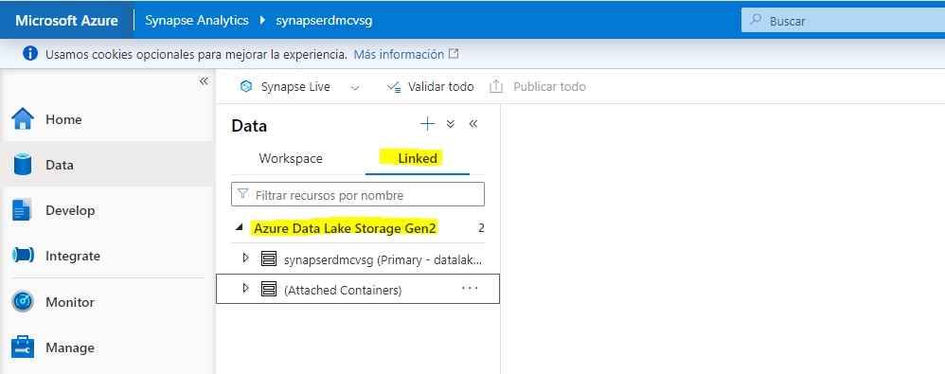

1. In the ****+**** menu, select ****Connect to external data****, and then select ****Azure Cosmos DB for NoSQL****.

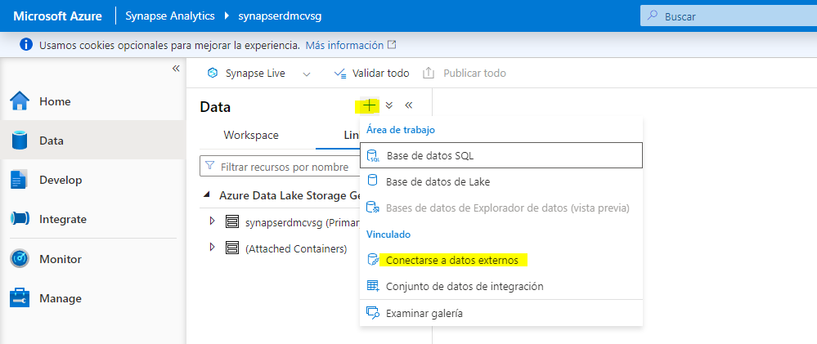

[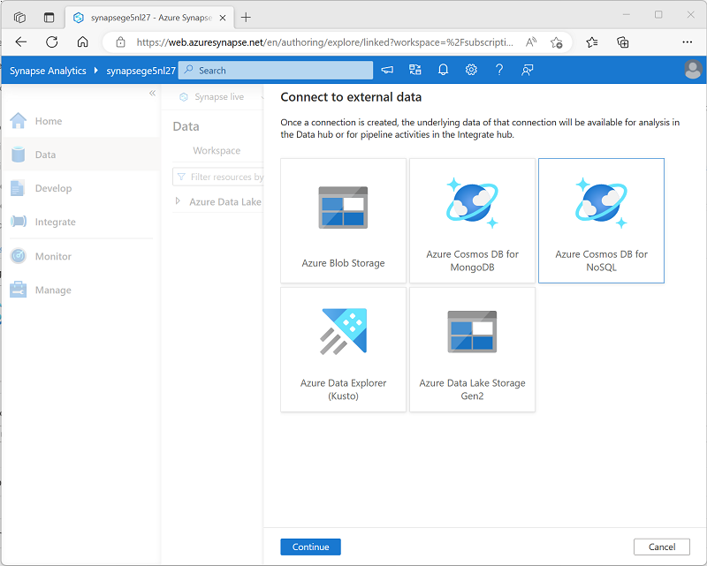](https://microsoftlearning.github.io/dp-203-azure-data-engineer/Instructions/Labs/images/add-cosmos-db-link.png)

1. Continue, and create a new Cosmos DB connection with the following settings:

* ****Name****: AdventureWorks
* ****Description****: AdventureWorks Cosmos DB database
* ****Connect via integration runtime****: AutoResolveIntegrationRuntime
* ****Authentication type****: Account key
* ****Connection string****: selected
* ****Account selection method****: From subscription
* ****Azure subscription****: select your Azure subscription
* ****Azure Cosmos DB account name****: select your ****cosmosxxxxxxx**** account
* ****Database name****: AdventureWorks

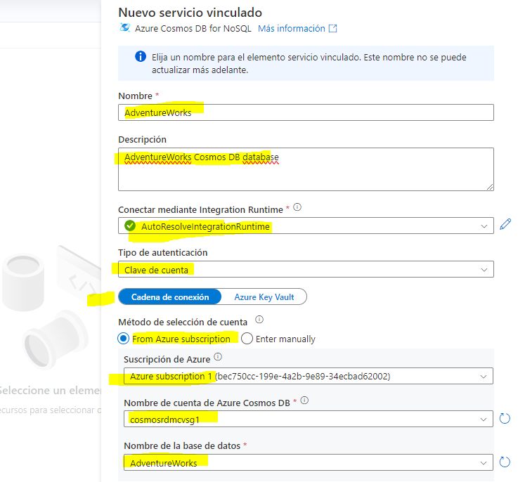

1. After creating the connection, use the ****↻**** button at the top right of the ****Data**** page to refresh the view until an ****Azure Cosmos DB**** category is listed in the ****Linked**** pane.

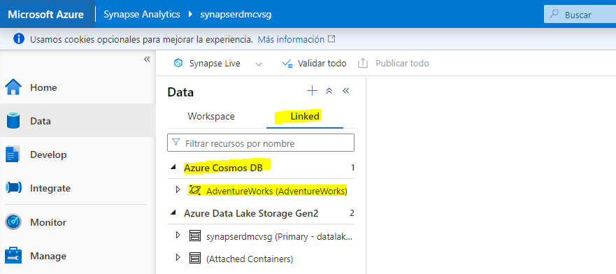

1. Expand the ****Azure Cosmos DB**** category to see the ****AdventureWorks**** connection you created and the ****Sales**** container it contains.

[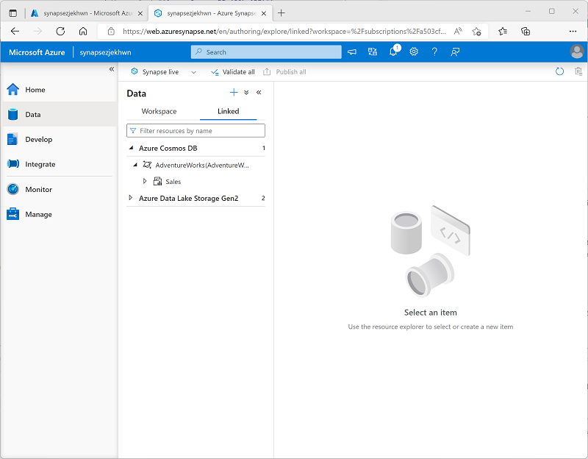](https://microsoftlearning.github.io/dp-203-azure-data-engineer/Instructions/Labs/images/cosmos-linked-connection.png)

## Query Azure Cosmos DB from Azure Synapse Analytics

Now you’re ready to query your Cosmos DB database from Azure Synapse Analytics.

### Query Azure Cosmos DB from a Spark pool

1. In the ****Data**** pane, select the ****Sales**** container, and in its ****…**** menu, select ****New Notebook**** > ****Load to DataFrame****.

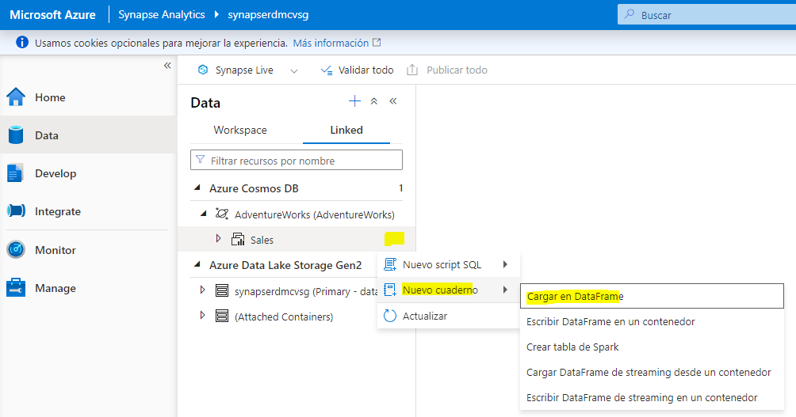

1. In the new ****Notebook 1**** tab that opens, in the ****Attach to**** list, select your Spark pool (****spark**xxxxxxx**). Then use the ****▷ Run all**** button to run all of the cells in the notebook (there’s currently only one!).

Since this is the first time you’ve run any Spark code in this session, the Spark pool must be started. This means that the first run in the session can take a few minutes. Subsequent runs will be quicker.

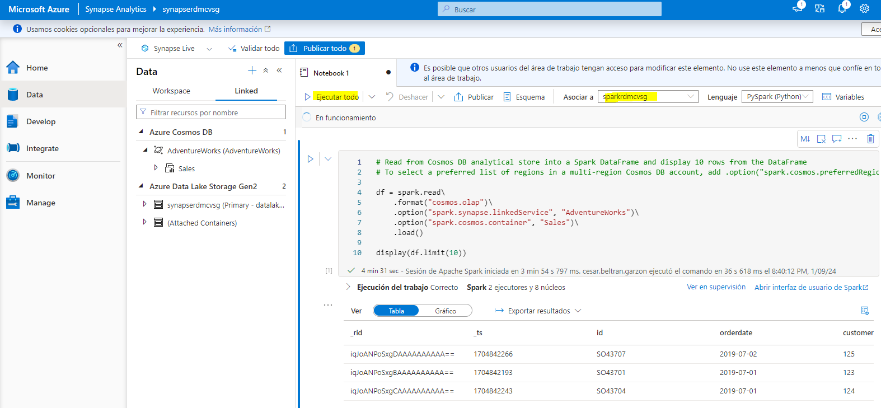

1. While you are waiting for the Spark session to initialize, review the code that was generated (you can use the ****Properties**** button, which looks similar to ****🗏\*****, on the right end of the toolbar to close the ****Properties**** pane so you can see the code more clearly). The code should look similar to this:

# Read from Cosmos DB analytical store into a Spark DataFrame and display 10 rows from the DataFrame

# To select a preferred list of regions in a multi-region Cosmos DB account, add .option("spark.cosmos.preferredRegions", "<Region1>,<Region2>")

df = spark.read\

.format("cosmos.olap")\

.option("spark.synapse.linkedService", "AdventureWorks")\

.option("spark.cosmos.container", "Sales")\

.load()

display(df.limit(10))

1. When the code has finished running, and then review the output beneath the cell in the notebook. The results should include three records; one for each of the items you added to the Cosmos DB database. Each record includes the fields you entered when you created the items as well as some of the metadata fields that were automatically generated.

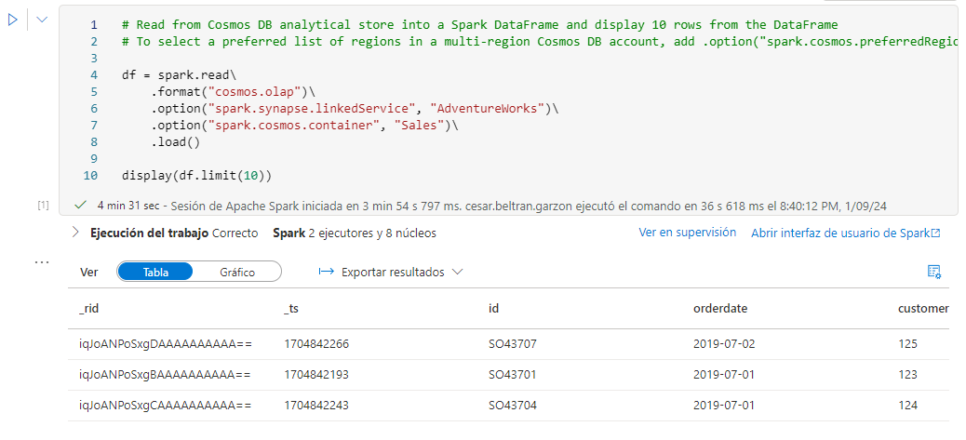

1. Under the results from the previous cell, use the ****+ Code**** icon to add a new cell to the notebook, and then enter the following code in it:

customer_df = df.select("customerid", "customerdetails")

display(customer_df)

1. Use the ****▷**** icon to the left of the cell to run it, and view the results; which should be similar to this:

| customerid | customerdetails |
| --- | --- |
| 124 | ”{“customername”: “Julio Ruiz”,”customeremail”: “julio1@adventure-works.com”}” |
| 125 | ”{“customername”: “Emma Brown”,”customeremail”: “emma3@adventure-works.com”}” |
| 123 | ”{“customername”: “Christy Zhu”,”customeremail”: “christy12@adventure-works.com”}” |

This query created a new dataframe containing only the ****customerid**** and ****customerdetails**** columns. Observe that the ****customerdetails**** column contains the JSON structure for the nested data in the source item. In the table of results that is displayed, you can use the ****►**** icon next to the JSON value to expand it and see the individual fields it contains.

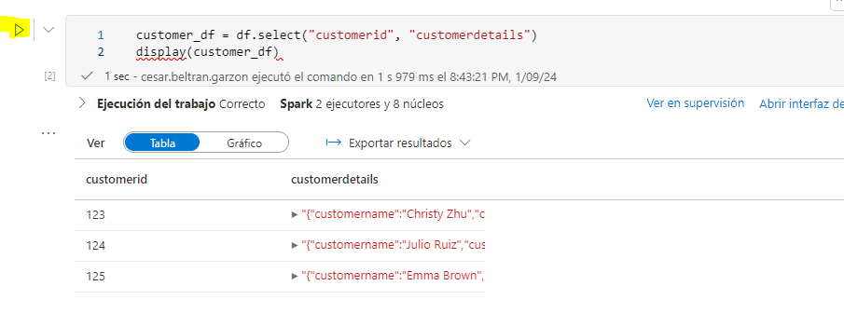

1. Add another new code cell and enter the following code:

customerdetails_df = df.select("customerid", "customerdetails.*")

display(customerdetails_df)

1. Run the cell and review the results, which should include the ****customername**** and ****customeremail**** from the ****customerdetails**** value as columns:

| customerid | customername | customeremail |
| --- | --- | --- |
| 124 | Julio Ruiz | julio1@adventure-works.com |
| 125 | Emma Brown | emma3@adventure-works.com |
| 123 | Christy Zhu | christy12@adventure-works.com |

Spark enables you to run complex data manipulation code to restructure and explore the data from Cosmos DB. In this case, the PySpark language enables you to navigate the JSON properties hierarchy to retrieve the child fields of the ****customerdetails**** field.

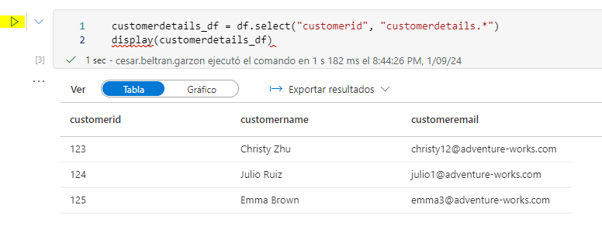

1. Add another new code cell and enter the following code:

%%sql

-- Create a logical database in the Spark metastore

CREATE DATABASE salesdb;

USE salesdb;

-- Create a table from the Cosmos DB container

CREATE TABLE salesorders using cosmos.olap options (

spark.synapse.linkedService 'AdventureWorks',

spark.cosmos.container 'Sales'

);

-- Query the table

SELECT *

FROM salesorders;

1. Run the new cell to create a new database containing a table that includes data from the Cosmos DB analytical store.

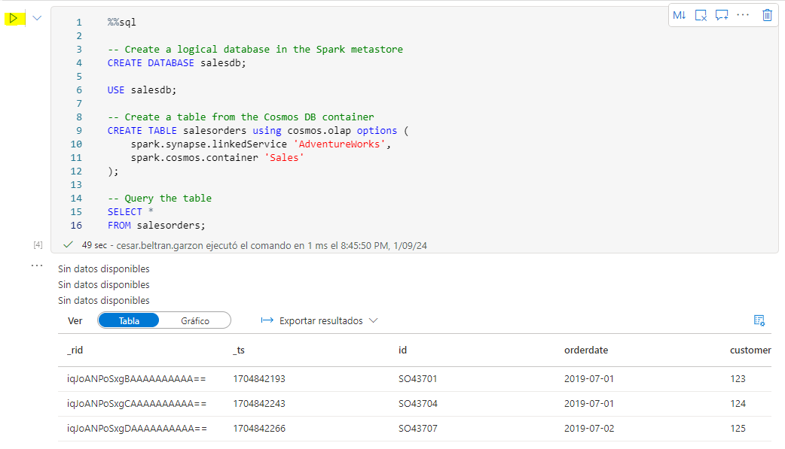

1. Add another new code cell, and then enter and run the following code:

%%sql

SELECT id, orderdate, customerdetails.customername, productFROM salesordersORDER BY id;

The results from this query should resemble this:

| id | orderdate | customername | product |
| --- | --- | --- | --- |
| SO43701 | 2019-07-01 | Christy Zhu | Mountain-100 Silver, 44 |
| SO43704 | 2019-07-01 | Julio Ruiz | Mountain-100 Black, 48 |
| SO43707 | 2019-07-02 | Emma Brown | Road-150 Red, 48 |

Observe that when using Spark SQL, you can retrieve named properties of a JSON structure as columns.

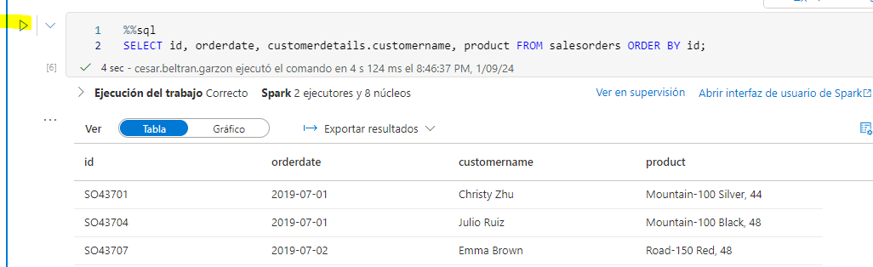

1. Keep the ****Notebook 1**** tab open - you’ll return to it later.

### Query Azure Cosmos DB from a serverless SQL pool

1. In the ****Data**** pane, select the ****Sales**** container, and in its ****…**** menu, select ****New SQL script**** > ****Select TOP 100 rows****.
2. In the ****SQL script 1**** tab that opens, hide the ****Properties**** pane and view the code that has been generated, which should look similar to this:

IF (NOT EXISTS(SELECT * FROM sys.credentials WHERE name = 'cosmosxxxxxxxx'))

THROW 50000, 'As a prerequisite, create a credential with Azure Cosmos DB key in SECRET option:

CREATE CREDENTIAL [cosmosxxxxxxxx]

WITH IDENTITY = ''SHARED ACCESS SIGNATURE'', SECRET = ''<Enter your Azure Cosmos DB key here>''', 0

GO

SELECT TOP 100 *

FROM OPENROWSET(​PROVIDER = 'CosmosDB',

CONNECTION = 'Account=cosmosxxxxxxxx;Database=AdventureWorks',

OBJECT = 'Sales',

SERVER_CREDENTIAL = 'cosmosxxxxxxxx'

) AS [Sales]

The SQL pool requires a credential to use when accessing Cosmos DB, which is based on an authorization key for your Cosmos DB account. The script includes an initial IF (NOT EXISTS(... statement that checks for this credential, and throws an error if it does not exist.

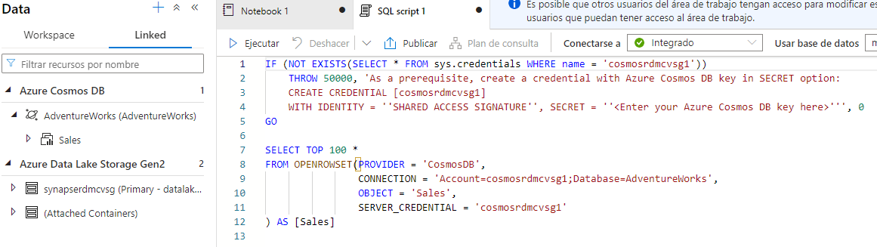

1. Replace the IF (NOT EXISTS(... statement in the script with the following code to create a credential, replacing cosmosxxxxxxxx with the name of your Cosmos DB account:

CREATE CREDENTIAL [cosmosxxxxxxxx]

WITH IDENTITY = 'SHARED ACCESS SIGNATURE',

SECRET = '<Enter your Azure Cosmos DB key here>'

GO

The whole script should now resemble the following:

CREATE CREDENTIAL [cosmosxxxxxxxx]

WITH IDENTITY = 'SHARED ACCESS SIGNATURE',

SECRET = '<Enter your Azure Cosmos DB key here>'

GO

SELECT TOP 100 *

FROM OPENROWSET(​PROVIDER = 'CosmosDB',

CONNECTION = 'Account=cosmosxxxxxxxx;Database=AdventureWorks',

OBJECT = 'Sales',

SERVER_CREDENTIAL = 'cosmosxxxxxxxx'

) AS [Sales]

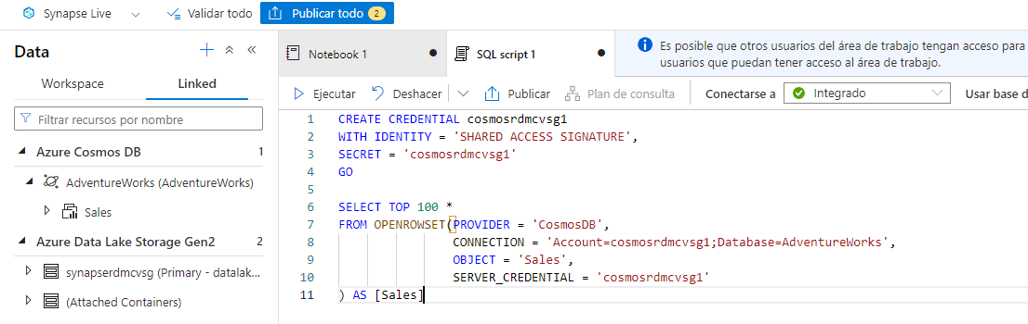

1. Switch to the browser tab containing the Azure portal (or open a new tab and sign into the Azure portal at [https://portal.azure.com](https://portal.azure.com/)). Then in the ****dp203-**xxxxxxx** resource group, open your ****cosmos**xxxxxxxx** Azure Cosmos DB account.

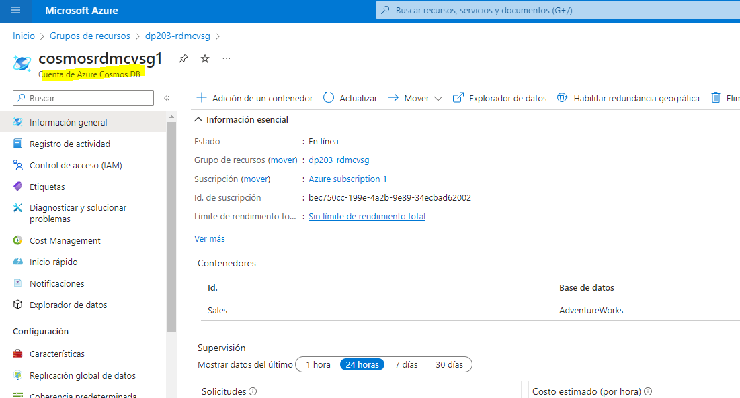

1. In the pane on the left, in the ****Settings**** section, select the ****Keys**** page. Then copy the ****Primary Key**** value to the clipboard.

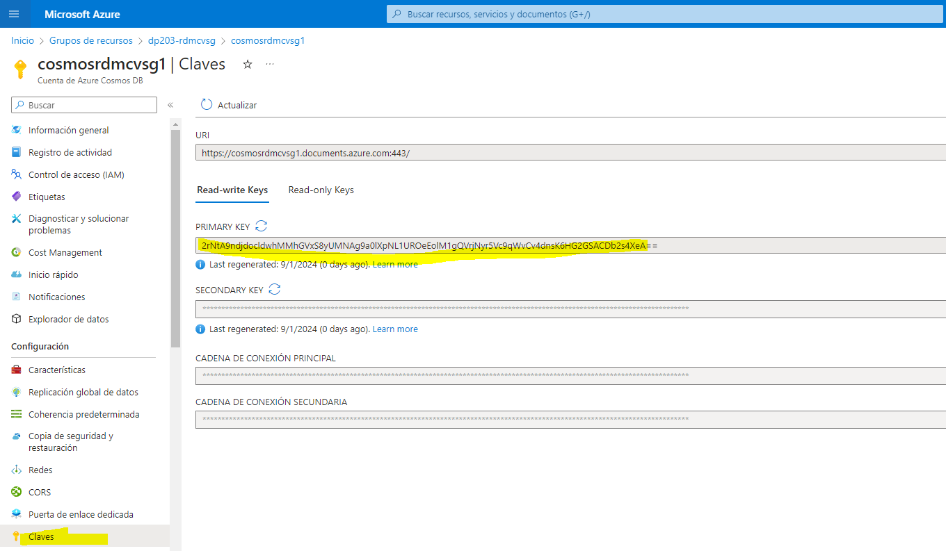

1. Switch back to the browser tab containing the SQL script in Azure Synapse Studio, and paste the key into the code replacing the **<Enter your Azure Cosmos DB key here>** placeholder so that the script looks similar to this:

CREATE CREDENTIAL [cosmosxxxxxxxx]

WITH IDENTITY = 'SHARED ACCESS SIGNATURE',

SECRET = '1a2b3c....................................=='

GO

SELECT TOP 100 *

FROM OPENROWSET(​PROVIDER = 'CosmosDB',

CONNECTION = 'Account=cosmosxxxxxxxx;Database=AdventureWorks',

OBJECT = 'Sales',

SERVER_CREDENTIAL = 'cosmosxxxxxxxx'

) AS [Sales]

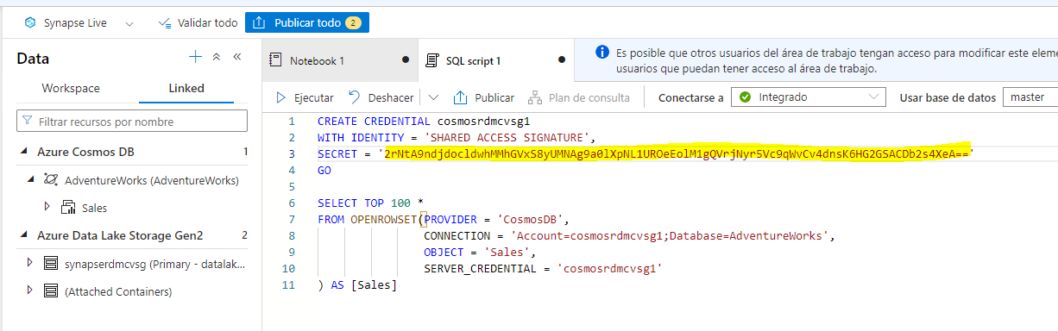

1. Use the ****▷ Run**** button to run the script, and review the results, which should include three records; one for each of the items you added to the Cosmos DB database.

Now that you have created the credential, you can use it in any query against the Cosmos DB data source.

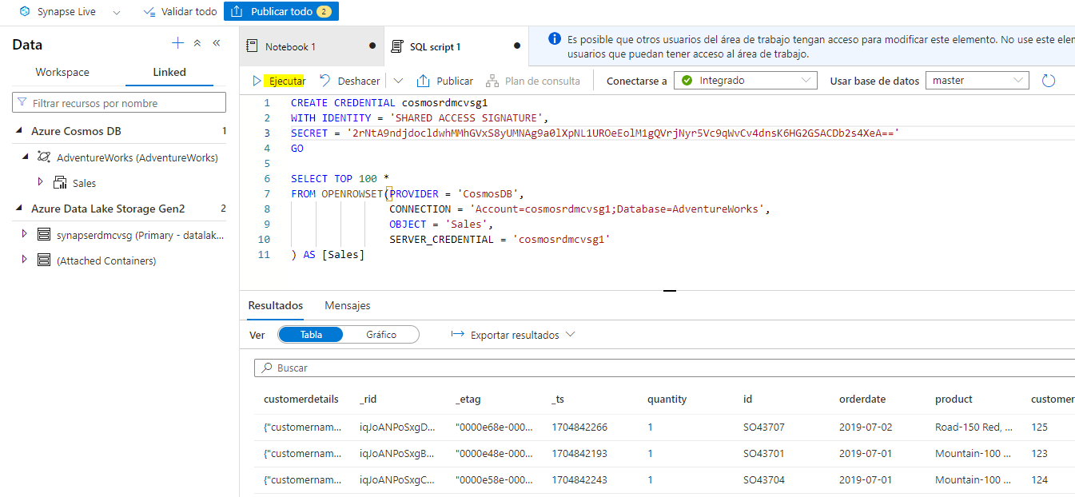

1. Replace all of the code in the script (both the CREATE CREDENTIAL and SELECT statements) with the following code (substituting cosmosxxxxxxxx with the name of your Azure Cosmos DB account):

SELECT *

FROM OPENROWSET(​PROVIDER = 'CosmosDB',

CONNECTION = 'Account=cosmosxxxxxxxx;Database=AdventureWorks',

OBJECT = 'Sales',

SERVER_CREDENTIAL = 'cosmosxxxxxxxx'

)

WITH (

OrderID VARCHAR(10) '$.id',

OrderDate VARCHAR(10) '$.orderdate',

CustomerID INTEGER '$.customerid',

CustomerName VARCHAR(40) '$.customerdetails.customername',

CustomerEmail VARCHAR(30) '$.customerdetails.customeremail',

Product VARCHAR(30) '$.product',

Quantity INTEGER '$.quantity',

Price FLOAT '$.price'

)

AS sales

ORDER BY OrderID;

1. Run the script and review the results, which should match the schema defined in the WITH clause:

| OrderID | OrderDate | CustomerID | CustomerName | CustomerEmail | Product | Quantity | Price |
| --- | --- | --- | --- | --- | --- | --- | --- |
| SO43701 | 2019-07-01 | 123 | Christy Zhu | christy12@adventure-works.com | Mountain-100 Silver, 44 | 1 | 3399.99 |
| SO43704 | 2019-07-01 | 124 | Julio Ruiz | julio1@adventure-works.com | Mountain-100 Black, 48 | 1 | 3374.99 |
| SO43707 | 2019-07-02 | 125 | Emma Brown | emma3@adventure-works.com | Road-150 Red, 48 | 1 | 3578.27 |

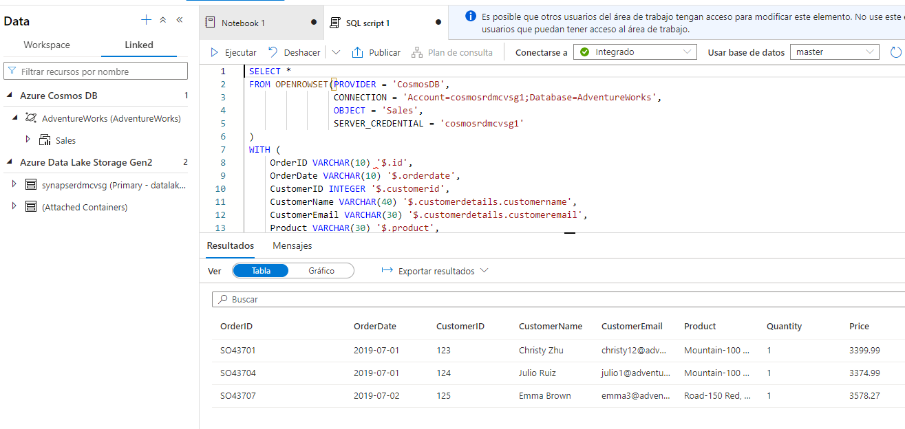

1. Keep the ****SQL script 1**** tab open - you’ll return to it later.

### Verify data modifications in Cosmos DB are reflected in Synapse

1. Leaving the browser tab containing Synapse Studio open, switch back to the tab containing the Azure portal, which should be open at the ****Keys**** page for your Cosmos DB account.
2. On the ****Data Explorer**** page, expand the ****AdventureWorks**** database and its ****Sales**** folder; and then select the ****Items**** folder.

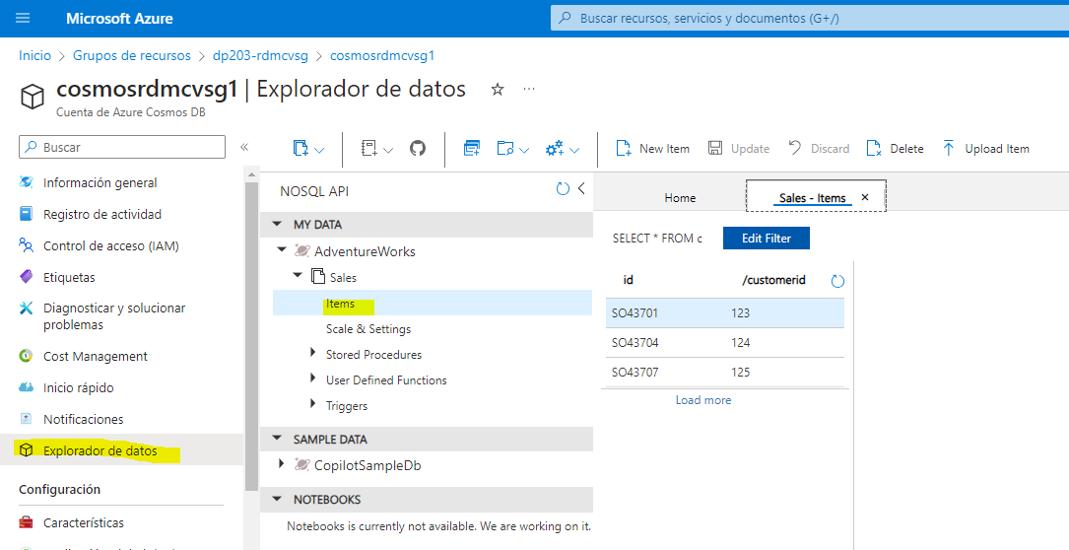

1. Use the ****New Item**** button to create a new customer item based on the following JSON. Then save the new item (some additional metadata fields will be added when you save the item).

{

"id": "SO43708",

"orderdate": "2019-07-02",

"customerid": 126,

"customerdetails": {

"customername": "Samir Nadoy",

"customeremail": "samir1@adventure-works.com"

},

"product": "Road-150 Black, 48",

"quantity": 1,

"price": 3578.27

}

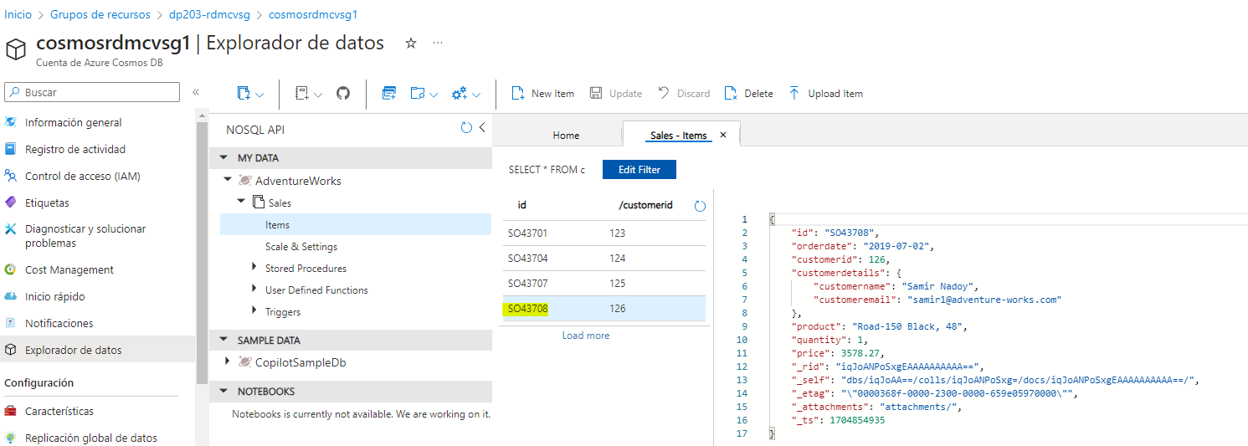

1. Return to the Synapse Studio tab and in the ****SQL Script 1**** tab, re-run the query. Initially, it may show the same results as before, but wait a minute or so and then re-run the query again until the results include the sale to Samir Nadoy on 2019-07-02.

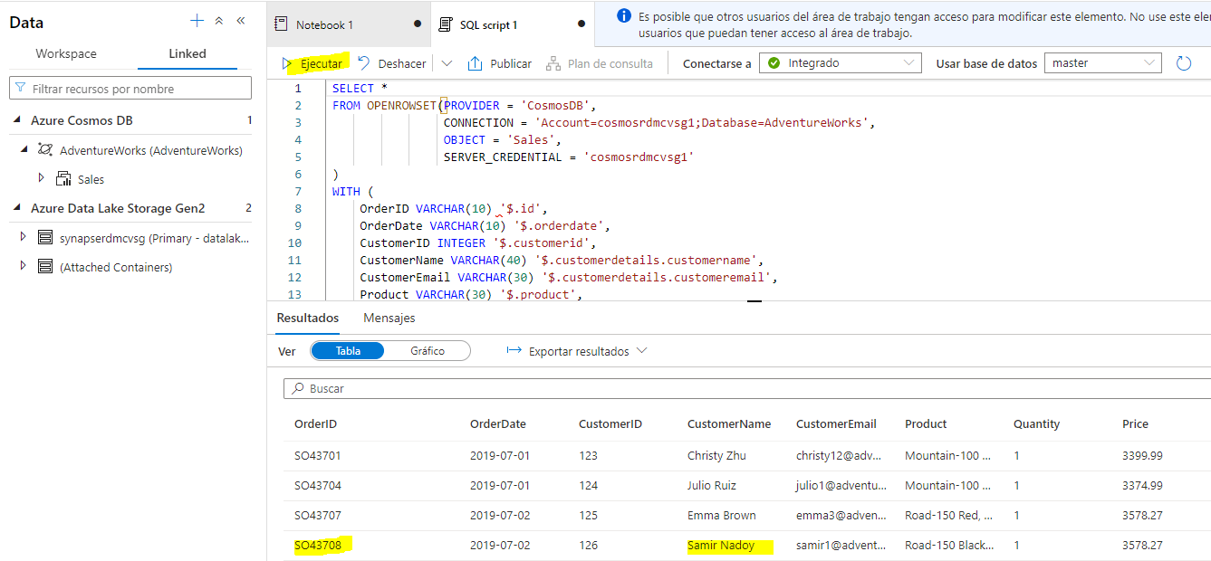

1. Switch back to the ****Notebook 1**** tab and re-run the last cell in the Spark notebook to verify that the sale to Samir Nadoy is now included in the query results.

## Delete Azure resources

If you’ve finished exploring Azure Synapse Analytics, you should delete the resources you’ve created to avoid unnecessary Azure costs.

1. Close the Synapse Studio browser tab and return to the Azure portal.
2. On the Azure portal, on the ****Home**** page, select ****Resource groups****.
3. Select the ****dp203-**xxxxxxx** resource group for your Synapse Analytics workspace (not the managed resource group), and verify that it contains the Synapse workspace, storage account, and Spark pool for your workspace as well as your Azure Cosmos DB account.
4. At the top of the ****Overview**** page for your resource group, select ****Delete resource group****.
5. Enter the ****dp203-**xxxxxxx** resource group name to confirm you want to delete it, and select ****Delete****.

After a few minutes, your Azure Synapse workspace resource group and the managed workspace resource group associated with it will be deleted.